ACKNOWLEDGEMENT

It gives me immense pleasure to present the project on Computer Science, titled Hand Cricket Simulation.

I would like to express my sincere thanks to the lord almighty for having given me good health for the completion of this project successfully. I would like to express my sincere thanks to the management and the principal Mrs. Eileen Jethro, M.A., B.Ed., MBA., HRM for giving me the opportunity to study in the well reputed and prestigious institution.

I would like to express my sincere gratitude towards my teacher in charge, Mr. David Paul, MCA., under whose guidance and constant supervision, the project has been completed. The motivations and suggestions given by him have been a major contribution towards the completion of the project.

I would also like to express my sincere thanks to my parents and friends for their encouragement and support towards completion of this project work. I am very thankful to CBSE for having given me this opportunity to understand the core economic principles and their applications in real world situations.

1. OVERVIEW OF PYTHON:

Python is a versatile, high-level programming language known for its simplicity, readability, and extensive standard libraries. Created by Guido van Rossum and first released in 1991, Python has gained widespread popularity in the software development community, becoming one of the most widely used languages for various applications.

Python is meant to be an easily readable language. Its formatting is visually uncluttered and often uses English keywords where other languages use punctuation. Unlike many other languages, it does not use curly brackets to delimit blocks, and semicolons after statements are allowed but rarely used. It has fewer syntactic exceptions and special cases than C or Pascal.

FEATURES OF PYTHON:
1. Syntax and Readability:
One of Python's standout features is its clear and straightforward syntax. The language emphasizes readability and reduces the cost of program maintenance. Python's use of indentation to denote code blocks, rather than relying on curly braces or keywords, makes it easy for developers to understand and write code. This simplicity contributes to the rapid development and debugging of programs.

2. Versatility and Applications:
Python is a general-purpose programming language that can be applied in a variety of domains. It is commonly used for web development, data analysis, artificial intelligence, machine learning, scientific computing, automation, and more. Frameworks like Django and Flask facilitate web development, while libraries such as NumPy and Pandas empower data scientists and engineers.

3. Dynamic Typing and High-Level Abstractions:
Python is dynamically typed, meaning variable types are assigned during runtime, providing flexibility but requiring careful attention to variable types. The language also features high-level abstractions that simplify complex operations. For example, Python handles memory management automatically through its built-in garbage collector, reducing the burden on developers.

4. Extensive Standard Libraries:
Python comes with a rich set of standard libraries that cover a wide range of functionalities, from handling regular expressions to networking and file I/O. These libraries eliminate the need for developers to build certain functions from scratch, allowing them to focus on higher-level aspects of their projects.

5. Community and Ecosystem:
The Python community is vibrant and supportive, contributing to a vast ecosystem of third-party packages and modules available through the Python Package Index (PyPI). This wealth of resources allows developers to leverage existing solutions, accelerating development and fostering collaboration.

6. Object-Oriented and Procedural Programming:
Python supports both object-oriented and procedural programming paradigms. This versatility enables developers to choose the approach that best fits their project requirements. The language's object-oriented features facilitate code organization and reuse, while procedural programming allows for straightforward script-like development.

7. Cross-Platform Compatibility:
Python is platform-independent, meaning Python code can run on various operating systems without modification. This cross-platform compatibility contributes to the language's popularity, as developers can create applications that work seamlessly on different environments.

In conclusion, Python's simplicity, readability, versatility, and strong community support make it an ideal choice for a wide range of applications. Its adaptability to different programming paradigms, extensive standard libraries, and vibrant ecosystem contribute to its status as a go-to language for both beginners and experienced developers.

RANDOM MODULE AND RANDINT FUNCTION:
The `random` module in Python provides a suite of functions for generating random numbers and performing randomization-related tasks. It is a versatile module commonly used in scenarios where unpredictability or randomness is desired. The module includes functions for generating random integers, floating-point numbers, and making random selections from sequences.

One notable function within the `random` module is `randint()`. The `randint()` function specifically generates random integers within a specified range. This function is particularly useful in situations where a random whole number within a given range is needed, such as simulating dice rolls, selecting random indices from a list, or creating randomized test data.

In summary, the `random` module in Python provides a range of tools for incorporating randomness into programs, with the `randint()` function being a key component for generating random integers within defined boundaries. The module is frequently employed in various applications, including gaming, simulations, and scenarios requiring randomized behavior.

2. PROJECT OVERVIEW:
2.1. INTRODUCTION:
During my Elementary school days, I used to play hand cricket with my friends during the recess. Hand cricket simulator allows you to play it with your computer and pass away time.

2.2. OBJECTIVE:
The project will serve the following objectives:
- Replicates a coin toss system to choose who bats first
- Allows player for both batting and bowling
- Inbuilt score keeping system
- Keeps a count of the number of balls played
- Calculates and declares the winner

2.3. EXISTING SYSTEM:
Hand cricket simulator can include multiple multiple wickets and even counts the number of overs bowled. It can also predict run rate and total runs to win the match. Few simulators even offer complex score keeping system which makes the game much more interesting to play.

2.4. PROPOSED SYSTEM:
The proposed system is a simple hand cricket simulator which provides turn based chances for batting and bowling to the user. It collects input as integers both for scoring runs and for bowling. The first batsman is decided by using a coin toss system. The final winner is announced by comparing the scores acquired by the player.

3. SYSTEM REQUIREMENTS:
3.1. SOFTWARE REQUIREMENTS:
- Windows 8 and above
- Python 3.9+
- Jupyter Notebook

3.2. HARDWARE REQUIREMENTS:
- At least 1 GB RAM
- Minimum of 512 MB Disk Space
- Any 4-core CPU like i3 9100F or better
- Processor with at least 1GHz speed

4. PACKAGES AND MODULES:
- random module

5. CONCLUSION:
A good game helps us to while away time. It can also help in controlling our stress and assist us in problem solving.Thus, the project “Hand Cricket Simulator” is completed successfully.

6. SOURCE CODE:

import random

print("""\t\t\t\tWelcome to Hand Cricket Simulation (Odd or even)
\t\t\t\t************************************************
Rules to Play:
\t1. All your input numbers should be between 1 to 6.
\t2. The computer will also select a number.
\t3. While batting, if the number selected by you and computer is different, then your number will add to your runs.
\t If the number selected by you and computer is same, then you will lose your wicket.
\t4. While bowling, if the number selected by you and computer is different, then computer's number will add to its runs.
\t If the number selected by you and computer is same, then the computer will lose its wicket.
\t5. Both the computer as well as the player gets one wicket.
\t6. Batting or bowling is chosen by toss.
\t7. The player continues to bat or bowl until you lose the wicket.
\t8. The player with maximum runs wins.\n""")

def gameinput(input_text):
# Function to get valid input from user
while True:
inputno = int(input(input_text))
if inputno >= 1 and inputno <= 6:
return inputno
else:
print("Enter a valid input number!\n")

def playtoss():
option = gameinput("Choose Heads (1) or Tails (2): ")
randHT = random.randint(1,2)

if randHT == 1:
print("Heads!")
else:
print("Tails!")

if randHT == option:
print("You won the toss!")
play = gameinput("Choose Bat (1) or Bowl (2): ")
if play == 1:
print("You are the batsman!")
elif play == 2:
print("You are the bowler!")
else:
print("Computer won the toss!")
play = random.randint(1,2)
if play == 1:
print("Computer chooses to bowl!")
elif play == 2:
print("Computer chooses to bat!")
print()
return play

def batting():
global pscore
global cscore
ballcount = 0
while True:
playeropt = gameinput("Choose any number from 1 to 6: ")
compopt = random.randint(1,6)
print(f"Computer plays {compopt}")
if playeropt == compopt:
print(f"Player loses his wicket. Score - {pscore}. Number of turns played - {ballcount}.\n")
return "pout"
else:
pscore += playeropt
ballcount += 1
print(f"Player's score is {pscore}")
print()

def bowling():
global cscore
global pscore
ballcount = 0
while True:
playeropt = gameinput("Choose any number from 1 to 6: ")
compopt = random.randint(1,6)
print(f"Computer plays {compopt}")
if playeropt == compopt:
print(f"Computer lost its wicket. Score - {cscore}. Number of turns played - {ballcount}.\n")
return "cout"
else:
cscore += compopt
ballcount += 1
print(f"Computer's score is {cscore}")
print()

pscore = 0
cscore = 0

# gamestate is either batting (1) or bowling (2) for the player
gamestate = playtoss()

if gamestate == 1:
batting()
# changing gamestate
gamestate = 2
print("Now its your Bowling turn.")
else:
bowling()
# changing gamestate
gamestate = 1
print("Now its your Batting turn.")

if gamestate == 1:
batting()
else:
bowling()

if pscore > cscore:
print("Player won the match! Congratulations!")
elif pscore < cscore:
print("Computer won the match. Better luck next time!")
elif pscore == cscore:
print("It's a tie! well played.")

7. OUTPUT SCREENSHOTS:

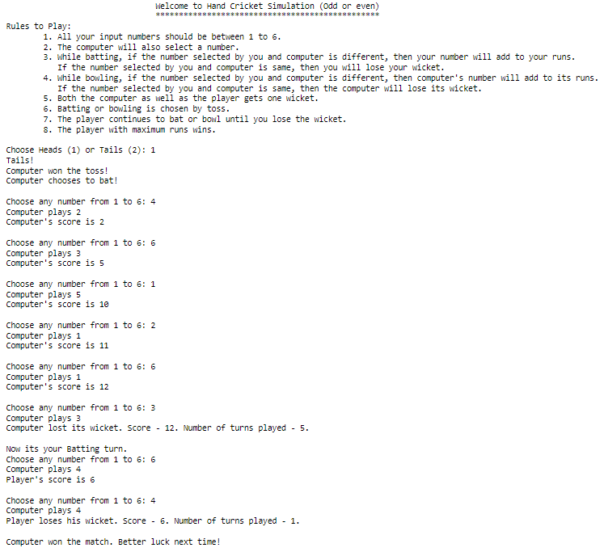
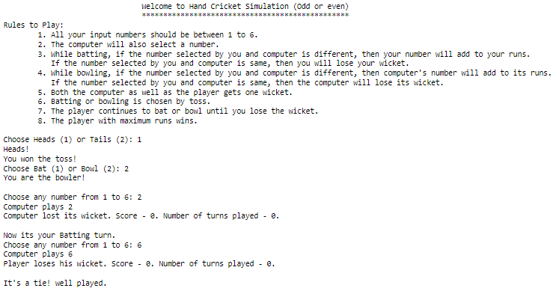
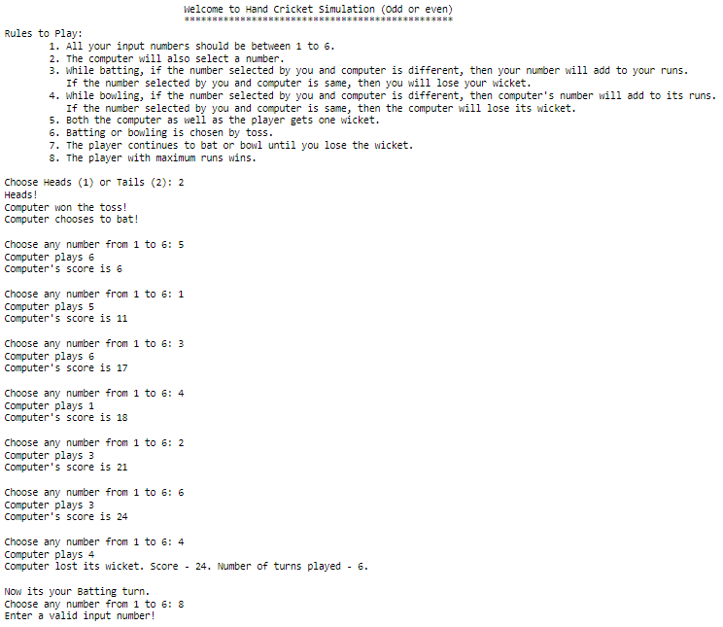

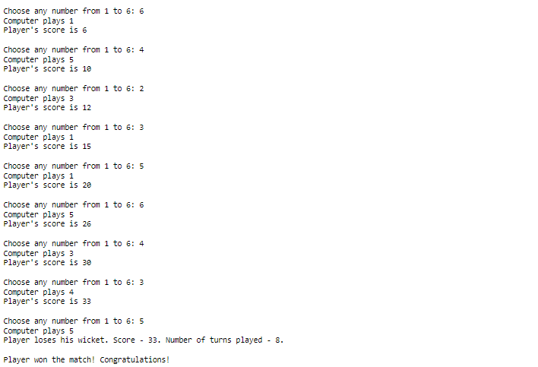
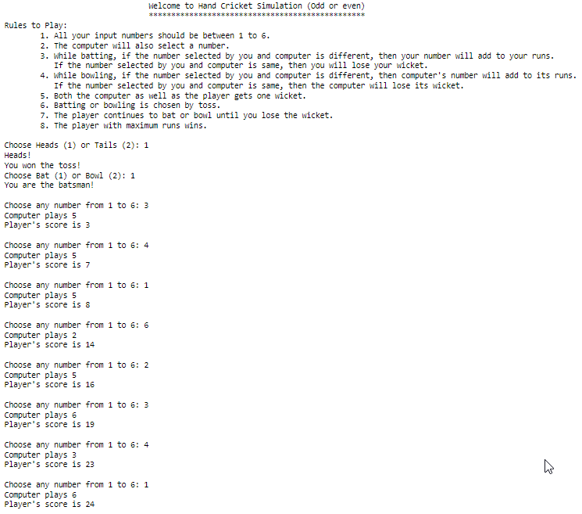
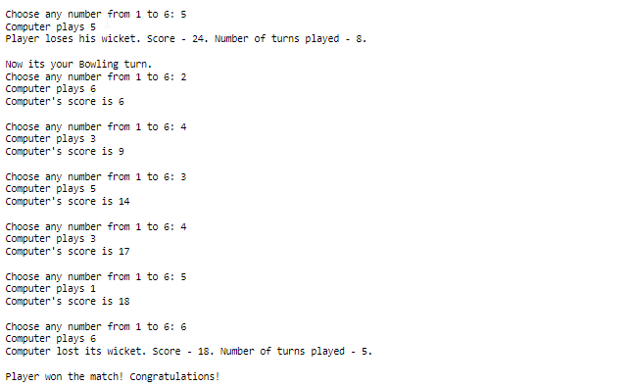
8. BIBILIOGRAPHY:
- Computer Science with Python (Class 11) – Preeti Arora
- Computer Science with Python (Class 12) – Preeti Arora
- https://en.wikipedia.org/wiki/Python_(programming_language)
- https://www.python.org/
- https://wiki.python.org/

